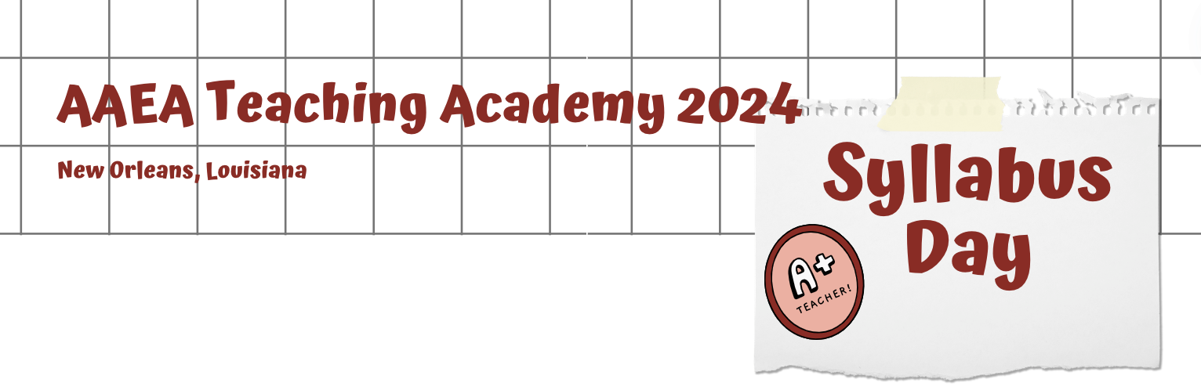
The syllabus is often the first interaction we have with our students. While many institutions have required text and sections that must be included, there is also a chance for us to inspire and connect with our students within the document.

One such way to connect with your students and create a welcoming environment on paper is to utilize inclusive language. A reminder that inclusive language is a way of speaking that avoids words and phrases that might exclude or discriminate against people based on their race, gender, socioeconomic status, or ability. It also aims to be sensitive to differences, convey respect, and promote equal opportunities. The syllabus is a chance for you to let the students know a little about you! Letting your personality show through will allow the students to feel they are welcome to be themselves too!

The following assignment is a chance for you to begin to think about how you might incorporate inclusive language and motivating language into your syllabus.

Task 1: Choose a specific course that you either intend to teach, would like to teach or have taught. Your institution may already have a course description for this course or you can find examples of very similar ones online. Your task is to write a new and improved description using “plain” language that will motivate and inspire students to invest in this class. If you struggle with this or aren’t sure where to start, try answering questions like why would the average person care about this topic, does this topic pop up in the news, how might this be used in a future career, etc.

Course Title:

Course Level (under grad/grad, freshman, etc.):

Daft Course Description:

Draft Welcome Message:
Task 2: Draft a welcome message to your students that could be included in your syllabus. You can include things like office hours and where they can find you, your hopes for the class, motivating words if there is a particular hard portion of the class, etc.

