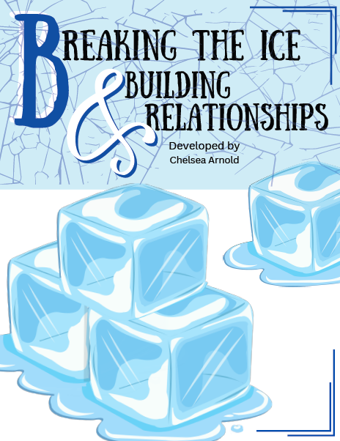


Ice Makers


Describe the worst icebreaker you have ever had to do?

What made it a terrible experience?

Circle any of the following that described
that experience:
ineffective
forced
awkward
tedious
uncomfortable
stressful
unengaging
confusing
stressful
poorly managed

Ice Breakers
Describe the best icebreaker you have ever had to do?

What made it a great experience?


Circle any of the following that described
that experience:
engaging
effective
energizing
innovative
creative
interactive
inclusive
memorable
inviting
well managed

Let’s Think
What are the ultimate goals of your icebreaker?
Rank them (1 being the most important)

___ Building Rapport
___ Finding group mates for class assignments
___ Setting expectations for collaboration
___ Student-to-student relationships
___ Building instructor-to-student relationships
___ Assess comfort & engagement levels
___ Gauge and promote critical thinking
___ Gauge student effort
___ Other: ______________________

How can icebreakers help create a community in your classroom and build relationships?

Now Reflect

Ideas I’ve heard today that are *perfect*:

Perfect for this course: ___________________

Ideas I’ve head today that *could* work:

Great idea for this course: ________________

Alterations?

Ideas I’ve heard today that I think would *never* work:

Why?

Notes

